1 – 1. Growth of functions. Teaching set

What Kind of Equation is Producing The Data?
Sometimes it’s helpful to know the characteristic type of growth for each family of functions.
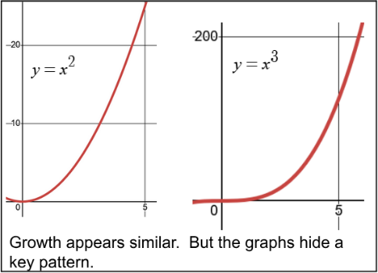
Looking at the graphs $y=x^{2}$ and $y=x^{3}$ you’d probably just say that $y=x^{3}$ grows faster.

If you look at the particular coordinates, there’s a key pattern that can help you fit the right kind of function for data you have.

You can discover it yourself if you look to see how much one y-value increases by to get to the next.

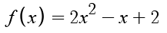
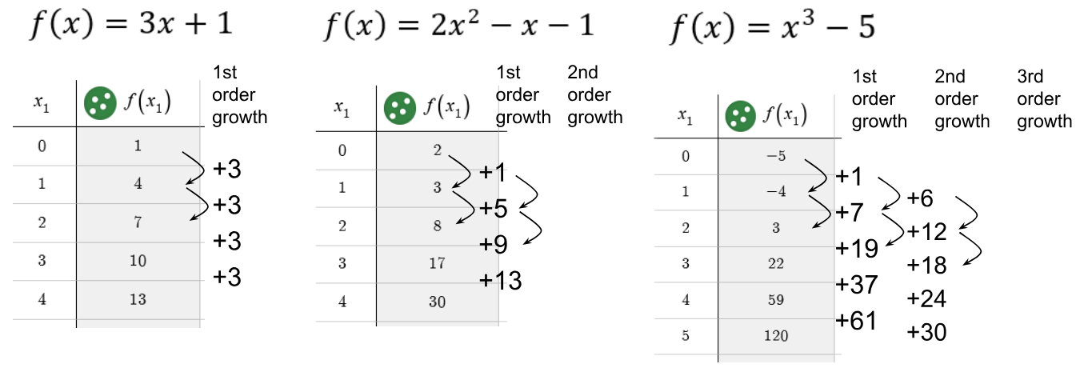
Here’s data from 3 different polynomials
a. Fill in the 2nd order growth (how the growth is growing) and the 3rd order growth (how the growth of the growth is growing).

b. What connections do you notice?

You can see the characteristics growth graphically as well
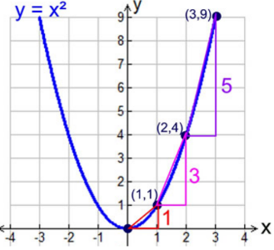
Growth triangles literally show how much the output increases each time the input increases by 1.

Here you can see that the heights of the growth triangles are all growing by 2. That constant second order growth happens for any quadratic function.

What about exponentials? How do you see their growth?

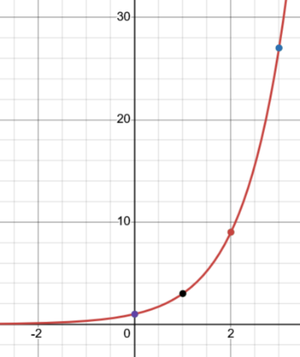
Many students see two different ways you might think about the growth for an exponential like this. Both are useful.
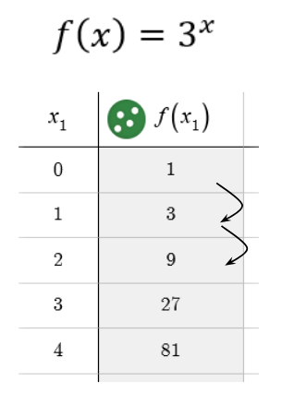


a. Try and describe the growth (by filling in the tables above) in two different ways.

b. What do you think is a good general rule for identifying exponential growth from data? Make it as specific as you can.

Does this example seem to match the growth for an exponential?
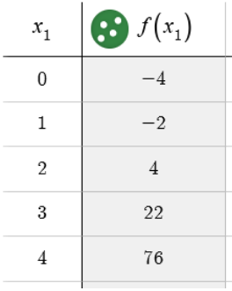
a. Try and apply your rule to this example. Is it an exponential function? If so, what can you say about the equation? If not, how do you know?

b. Look at growth triangles, or 1st and 2nd order growth and try and figure out if your rule worked or not.

1 – 1. Growth of functions. Teaching set
Sometimes it’s helpful to know the characteristic type of growth for each family of functions.

Looking at the graphs $y=x^{2}$ and $y=x^{3}$ you’d probably just say that $y=x^{3}$ grows faster.

If you look at the particular coordinates, there’s a key pattern that can help you fit the right kind of function for data you have.

You can discover it yourself if you look to see how much one y-value increases by to get to the next.



Here’s data from 3 different polynomials
+6
+6
+6
+6
+4
+4
+4
What connections do you notice?
One connection is that the level you hit constant growth tells you what kind of equation.
Constant 1st order growth matches the equation with $x^{1}$ power in it (the linear equation)
Constnat 2nd order growth matches the equation with $x^{2}$ in it (2nd degree equation)
Constant 3rd order growth matches the equation with $x^{3}$ in it (3rd degree equation)

You might have noticed that the 1st output number in each table matches the constant term for the equation. (The 1 matches the +1, the 2 matches the +2, and the -5 matches the -5).

You might have noticed that the +3 constant growth for $f\left(x\right)=3x+1$ matches the coefficient for x
(the slope). Does the actual growth number tell you anything about the coefficients in the other equations?

The +4 constant 2nd order growth doesn’t match any coefficients for $f\left(x\right)=2x^{2}-x-1$ but weirdly is twice the coefficient for $x^{2}$ (and twice the constant +2 at the end). Is that significant or just coincidence? That’s the kind of thing mathematicians are always noticing and trying to figure out.

You can see the characteristics growth graphically as well

Growth triangles literally show how much the output increases each time the input increases by 1.

Here you can see that the heights of the growth triangles are all growing by 2. That constant second order growth happens for any quadratic function.

What about exponentials? How do you see their growth?


Many students see two different ways you might think about the growth for an exponential like this. Both are useful.



+ 2
+ 6
+ 18
+ 54
*3
*3
*3
*3

If you look at how much each y-value increases that’s additive growth because you’re asking: how much needs to get added to each y-value to get the next one.

If might have noticed that if you multiply each y-value by 3, you get the next one. You might call this multiplicative growth.

Once you’ve spotted that constant multiplying growth, you might see it in the first table as well.

+ 2
+ 6
+ 18
+ 54

* 3
* 3
* 3
If you look at the 2nd and 3rd and 4th order additive growth, you’ll never reach a constant. But at every level, the growth will have this same multipliciative relationship.

That’s a signal that exponential equations are a fundamentally different kind of growth from $x$ or $x^{2}$ or $x^{3}$ or $x^{4}$ or any equations built from those elements. (We call those polynomials, by the way).

Understanding the growth of functions more deeply is a large part of what calculus is about. Everything we looked at here will continue to be used, developed, and your understanding will get deeper as you go along.
A Wrinkle: Does this example seem to match the growth for an exponential?

Based on the last example, you might have thought: “constant multiplying of y-values means exponential function”

This equation is $f\left(x\right)=3^{x}-5$. It’s an exponential function, but the y-values don’t have constant multiplicative growth.

Did this example break your rule? The way I phrased the “rule” above was intentially vague. It might actually mean two completely different things.

Here are two things the “rule” might have meant:
“IF you see constant multiplicative growth in y-values THEN you have an exponential equation”
“IF you have an exponential equation THEN it will have constant multipliciative growth in the y-values”

b. Look at growth triangles, or 1st and 2nd order growth and try and figure out if your rule worked or not.

